SECTION 28 00 00 – ELECTRONIC SECURITY SYSTEMS
- ALARM BEACON
      - Provide data connection.
      - Connect to intercom system.
      - Typical locations:
        - Main corridors.
        - Public spaces.
        - Commons.
        - Study locations.
        - Vending.
        - Main lobby.
        - Assembly spaces.
        - Auditoriums.
        - Other locations as directed by the College.
- ADDITIONAL SECURITY
      - Provide security controls for lockdown procedures. Locate controls as directed by the College.
      - IP access control and IP surveillance systems shall allow for partitioning.
      - Provide panic buttons as directed by the college. Panic buttons can be hard-wired or wireless.
        - Typical locations:
          - Bursar office.
          - Food service.
          - Front reception at main entrance.
          - Bookstore.
          - All point of sale locations (POS).
          - Locations where money is exchanged.
      - Provide 911 panels. Locate as directed by the College.
      - Provide AED devices with necessary connections. Coordinate location with College.

SECTION 28 13 00 – ELECTRONIC ACCESS CONTROL
      - Provide electronic access control (card/FOB access) at key entrances and other high-security spaces as directed by the College.
      - Lenel S2 is Standard Access Control System. S2 system ties into Atertus Technologies Mass Notification System.
      - Electronic control will be able to be expandable.
      - Provides door position switches on all exterior doors and interior doors with electronic access control.
      - Provide ability to lock down all doors via software or secured central button.
      - Typical locations for electronic access control:
        - All exterior doors.
        - Technology rooms including TR and ER.
        - Bursar office.
        - Human Resources office.
        - Computer and other labs.
        - Chancellor suite.
        - Office suites.
        - Facilities rooms.
        - “Specialty areas” or high-value areas.
        - Electrical rooms.
      - Additional locations for electronic access control for consideration. Provide rough-in for future access control in the following locations:
        - Industrial Technology/Advanced Manufacturing labs.
        - Science labs.
        - Culinary labs.
        - Nursing/Medical labs.
      - For maximum safety, doors including classrooms, to have a thumb-turn on interior side and keyed from the outside.
      - Security and facilities to have access to physical keys.
      - General classrooms to have a physical key.
SECTION 28 23 00 – VIDEO SURVEILLANCE SYSTEM
      - Owner (College) will provide video surveillance cameras to cover entrances, corridors, parking lots, and other high-security areas.
      - Provide Raid Level 5 storage for surveillance video data.
      - Systems to be provided by the College, approved by the Vice President of PSEP or their designee.
      - System to be actively monitored.
      - System must come with a manufacturer-supported maintenance agreement.
      - Storage approach:
        - Storage should include archival data for a minimum of 30 days.
        - Provide Raid Level 5 storage for local surveillance video data.
        - Cloud storage is an acceptable approach.
        - Combination cloud and local also an acceptable approach if meets retention criteria.
      - Guidelines for camera placement:
        - Locate cameras during design phase before construction starts with the approval of the Vice President for PSEP or their designee. This process is critical to ensure no issues are realized during construction.
        - Visibility is required in all hallways to follow movement.
        - Visibility is required at all exterior walls.
        - Exterior cameras
          - Additional cameras on the buildings for visibility of all exterior walls.
        - Interior cameras
          - Need visibility of all hallways to follow movement.
          - Single-head cameras can be used in individual rooms or facing a doorway.
          - No single head cameras in corridors.
          - If feasible, use 4-way cameras at corridor intersections.
          - No PTZ cameras.
      - Cabling for Cameras:
        - Contractor will install wire and cabling to identified locations. Interior and exterior camera cable runs within 300’, use shielded CAT6. For longer runs, including out to parking lot poles, fiber is required.
        - Provide PoE for all cameras including fiber runs to exterior.
        - Outdoor cameras are typically mounted on the building.
        - Camera cabling to be shielded.
        - Cable typically must be neatly run and labeled in conduit. In some circumstances, and if approved by the College, cable on j-hooks above ceilings is acceptable.

EXHIBITS
      - Suggest adding typical diagram for TR such as (Ivy Tech to indicate requested revisions):

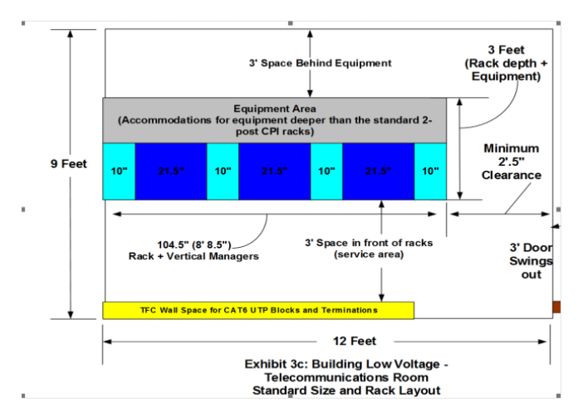
      - Typical locations for locations for cable tray, J hooks.
      - Diagram with stacked IT closets.
        - Example including both numbers 3 and 4 above (Ivy Tech to indicate requested revisions):

