Dental Hygiene
Fall Information Session
December 5, 2026
Anderson Campus

104 West 53rd Street

Room 311

Registration is requested
RSVP Here:

https://forms.cloud.microsoft/r/8zidSdhbJU
Information presentation begins at 9:00 a.m. followed by clinic tours.
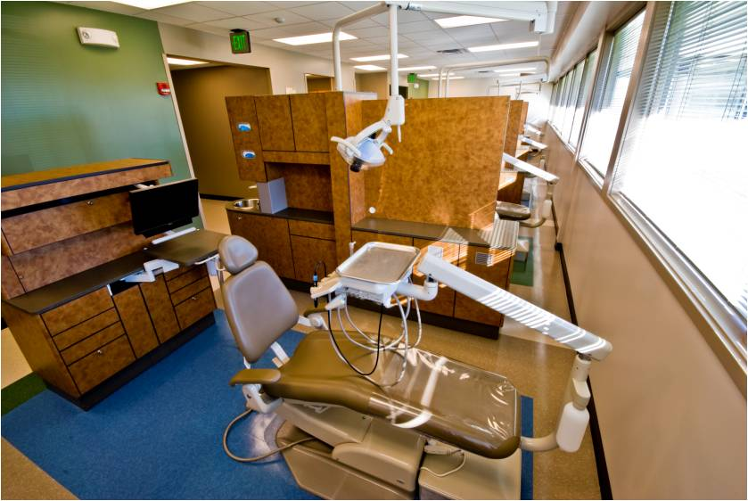
Participants are asked to be on time and stay for the entire presentation.

